Newsletter Issue 5

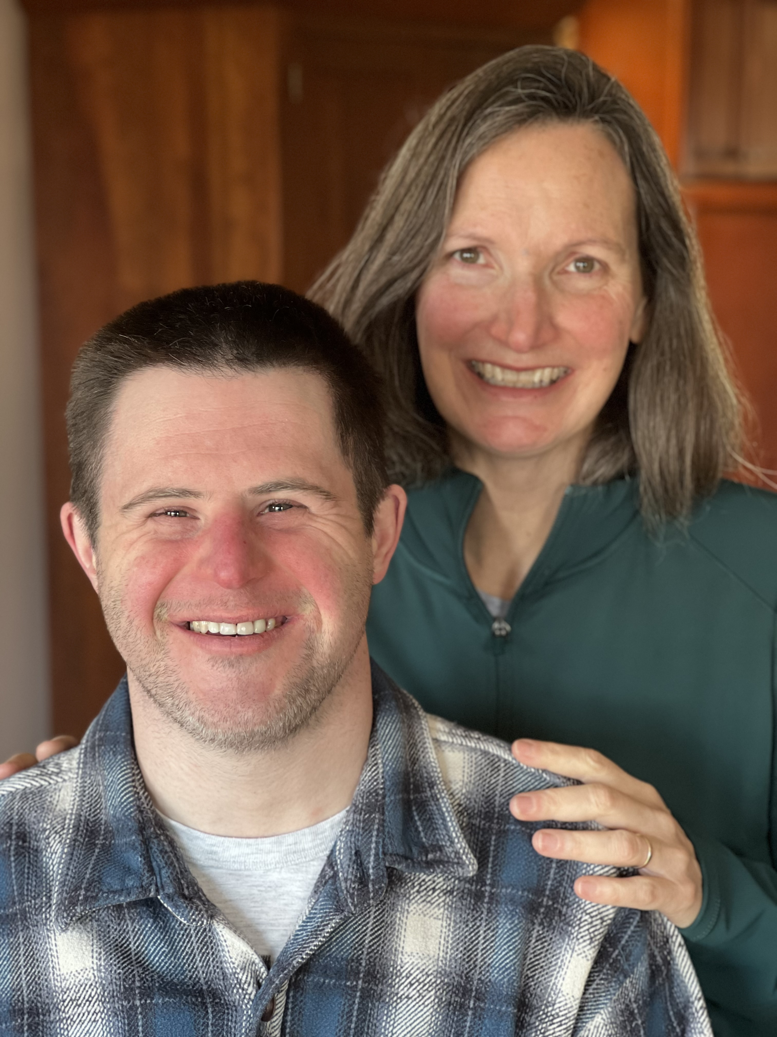

As we are at the beginning of the respiratory infection season, it is important to remember the increased risk for people with Down syndrome from viruses and pneumonia. In my career, it was not infrequent during the winter for a patient of mine to be intubated in the PICU for an extended period of time. During the early covid pandemic before we had vaccines, people with Down syndrome had 10 times the risk of death from COVID compared to people without Down syndrome. We are fortunate to now have vaccines against flu, COVID, RSV, and pneumonia, and to be able to help decrease the risk for those in the DSANEO community.

Respiratory Infections
Janoff EN, Tseng HF, Nguyen JL, Alfred T, Vietri J, McDaniel A, Chilson E, Yan Q, Malhotra D, Isturiz RE, Levin MJ. Incidence and clinical outcomes of pneumonia in persons with down syndrome in the United States. Vaccine. 2023 Jul 12;41(31):4571-4578. doi: 10.1016/j.vaccine.2023.05.063. Epub 2023 Jun 14. PMID: 37328350.
https://www.sciencedirect.com/science/article/pii/S0264410X23006242?via%3Dihub
People with Down syndrome had higher rates of all-cause pneumonia, pneumococcal pneumonia, invasive pneumococcal disease, and influenza, which led to higher rates of admission to the hospital and ICU.

Advocate Medical Group Adult Down Syndrome Center is one of the largest Adult Down Syndrome Clinics in the United States. This is from their website. “Down syndrome is not specifically listed as a "certain medical condition" that indicates that someone should get a pneumococcal vaccine between the ages of 19 and 64. However, as mentioned above, pneumonia occurs more frequently in people with Down syndrome. Additionally, immune system deficiency (which is listed above) is a common finding in people with Down syndrome. Therefore, at the Adult Down Syndrome Center, we include Down syndrome in the list of conditions that indicates that someone between the ages of 19 and 64 should be vaccinated against pneumococcal disease.”
https://adscresources.advocatehealth.com/https://adscresources.advocatehealth.com/pneumonia-vaccine/

Also, this app from the CDC provides information on pneumococcal vaccines.
https://www.cdc.gov/vaccines/vpd/pneumo/hcp/pneumoapp.html

Aging
Landes SD, Stevens JD, Turk MA. Cause of death in adults with Down syndrome in the United States. Disabil Health J. 2020 Oct;13(4):100947. doi: 10.1016/j.dhjo.2020.100947. Epub 2020 Jun 10. PMID: 32680774; PMCID: PMC7655667.
https://www.ncbi.nlm.nih.gov/pmc/articles/PMC7655667/
The risk of dying in people with Down syndrome significantly increases after age 40. There was increased risk of death from dementia, congenital heart defects, respiratory issues and choking. Adults with Ds had 12 times the risk of death of dying from choking. The article emphasized the need to pay attention to dysphagia and feeding issues in adults.

Updated resource on aging and end of life from the National Down Syndrome Society. Available for digital download. Great for clinicians and parents. People with Down syndrome undergo premature aging, signs of this can be seen even in their thirties and clinical signs of Alzheimer’s disease can begin in the 40s. These resources can help caregivers anticipate and plan for changes that may occur as their loved one ages.
https://ndss.org/resources/aging-and-down-syndrome-health-well-being-guidebook
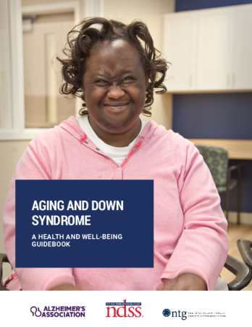

https://ndss.org/resources/end-life-and-down-syndrome

Free CME
On demand course from Harvard Medical School, Clinical Care for Autistic Adults.

https://cmecatalog.hms.harvard.edu/clinical-care-for-autistic-adults

Resource for parents and caregivers
Mindfulness Series
Many people with disabilities have experienced trauma and this affects behavior and coping skills. This series explains trauma, the behaviors it can cause, and how mindfulness can be used to support individuals and their caregivers. I attended the course in real time and learned so much that helped me. A great resource for your patients and their families.
https://dodd.ohio.gov/about-us/MIID/Trauma-Sensitive-Mindfulness

Medicaid Waivers
Waivers can be very confusing but are an important source of financial support for adults with disabilities.
This website will help parents learn about waiver.
https://ddc.ohio.gov/resources-and-publications/medicaid-waivers
This webinar will also help parents understand the system and the coming changes.
